**PAM Strategic Initiative -**

**Accessing Ocean Sounds to Inform Protected Species and Climate Trends**

**PAM SI Team:**

Sofie Van Parijs, NMFS NEFSC (SI lead)

Catherine Berchok, NMFS AFSC

Jason Gedamke, NMFS S&T

Marla Holt and David Huff, NMFS NWFSC

Erin Oleson, NMFS PIFSC

Shannon Rankin- NMFS SWFSC

Melissa Soldevilla, NMFS SEFSC

Carrie Wall Bell, NOAA NCEI

**PAM SI - Vision Roadmap**

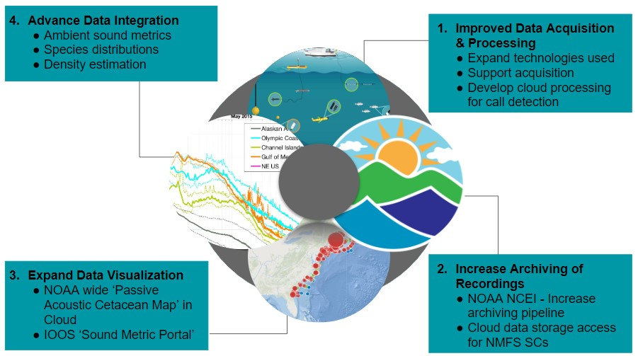

**Background:**

NMFS’ Passive Acoustic Monitoring (PAM) programs focus on collecting underwater sound recordings of the marine environment. Identification of the sounds produced by protected marine mammal species, fishes, or humans allows for an understanding of marine soundscapes. PAM data collection provides information on changes in species distribution, behavior and/or density, in addition to assessing impacts of man made noise. The technological revolution in PAM over the past decade has allowed both acoustic recorders and analytical approaches to increasingly become an integral part of NMFS’s core science mission. PAM’s capacity for creating long term time series makes it an ideal approach for evaluating changes in species stocks, ecosystem interactions and climate change. There currently are 7 NMFS PAM programs including each NMFS Science Center and the S&T’s Ocean Acoustic Program. PAM data can be archival (recorder needs to be recovered at sea before data can be accessed) or real time (data is transmitted via cable or satellite as it is collected). Currently, NMFS PAM programs use all available acoustic platforms from stationary bottom mounted to mobile towed, drifting, or UxS platforms. However, each program varies in the level of technological development and operational capacity. Over the next 4 years we aim to work to resolve the core roadblocks that hold back PAM’s ability to be fully operational across NMFS.

**Transformational Activities:**

Our proposed transformational activities focus on four areas as reflected in our Vision Roadmap (see above).

1. **Improved Data Acquisition and Processing:** Support for regular PAM data collection is essential to address species or regional data gaps and build long term records that will allow for an improved understanding of species distributional changes and effects of changing ocean conditions. Capacity building for PAM data collection will focus on expansion of PAM archival data collection, the Noise Reference Station efforts and implementing PAM into gliders for data collection at a Pacific-wide level. Collaboration will occur between NMFS SCs to find common needs for software development to allow data processing in the cloud as well as improved software package development (e.g. PamPal) and accessibility of complementary data streams (e.g., AIS).
2. **Increased Archiving of Recordings**: All 7 PAM programs will identify key projects and platform types and work with [NOAA’s NCEI](https://www.ncei.noaa.gov/products/passive-acoustic-data) to improve their data flow and capacity for archiving PAM recordings. In addition, NMFS SCs struggle massively with storage capacity for PAM recordings. As part of this effort we will explore the ability to access Google Cloud storage.
3. **Expand Data Visualization Products:** Access to visual tools that enable managers, industry and research partners to explore PAM data to inform key decision making such as permitting, wind energy development, mitigation of entanglement and ship strike is a core need for our organization. We will leverage the IRA NARW efforts to improve data visualization of PAM data products for managers by creating a NMFS wide [Passive Acoustic Cetacean Map](https://apps-nefsc.fisheries.noaa.gov/pacm/#/) portal. Additionally we will leverage efforts by NOAA NCEI, ONMS, NMFS and IOOS to further develop the [SanctSound](https://sanctsound.portal.axds.co/) portal for visualizing and comparing ocean sound metrics across recording technologies and regions.
4. **Advance Data Integration:** PAM data integration and analytical development is essential to be able to improve the utility of this technology to answer core NMFS needs. We will focus on three areas of analytical product development,
   * Improve PAM ability to provide density and seasonal distribution estimates for protected species
   * Analysis of ambient noise metrics across all NMFS archived recordings at NOAA’s NCEI via software run within the Cloud
   * Decadal comparison of marine mammal acoustic species detections from long-term studies (e.g., IRA NARW, LISTEN GOMex, DBO)

**PAM SI - Synergies**

